Understanding Class Definitions
Concepts to be covered
- Fields
- Constructors
- Methods
- Parameters
- Assignment standards

TicketMachine – an overview
The observation of a program from an outside-looking-in perspective is called black box testing.
- Exploring the behaviour of a typical ticket machine.
  - Use the naive-ticket-machine project
  - Machines supply tickets of a fixed price.
    - How is the price determined?
  - How is “money” entered into a machine?
  - How does a machine keep track of the money that is entered?
Constructors can have parameters, just as how methods can have parameters.
From black box testing, I have observed:
- You can still print tickets without the sufficient balance
- You can insert negative values for money
- The machine doesn’t return change
- The program doesn’t specify you need to use pence instead of pounds
Interacting with an object gives us clues about its behaviour.
- Looking inside allows us to determine how that behaviour is provided or implemented.
- All Java classes have a similar looking internal view

Basic Class Structures
In the editor
- The green background represents the framework of the entire class
- The yellow background indicates the constructors and methods of the class
- “/**” indicates the start of a comment. It ends with “*/”.
public class TicketMachine { } → the outer wrapper
public class ClassName
{
Fields
Constructors → the inner contents of a class
Methods
}
By convention, the name of the class always starts with capital letter.
If they are compound names, each word is separated by capitalisation (camel case).
Keywords are words with a special meaning in the language:
- public
- class
- private
- int
These are also known as reserved words and are always entirely lower case.
The field definitions in the class specify what objects will later have.
- Fields store values for an object.
- They are also known as instance variables.
- You can use Inspect to view the state.
- Some values change often, whilst others don’t change, or change rarely.
- By convention, variable names always starts with lower case letters.

public class TicketMachine
{
private int price; → [visibility modifier] [type] [variable name];
private int balance; → By convention, it starts with a lower case letter.
private int total;
[…]
}
Constructors initialise an object.
- By convention, they have the same name as their class
- They store initial values into the fields
- Parameter values are often used for these.
public TicketMachine(int cost)
{
price = cost; → initialised field with parameter
balance = 0; → initialised field
total = 0;
}
Passing data via parameters – parameters are another sort of variable.
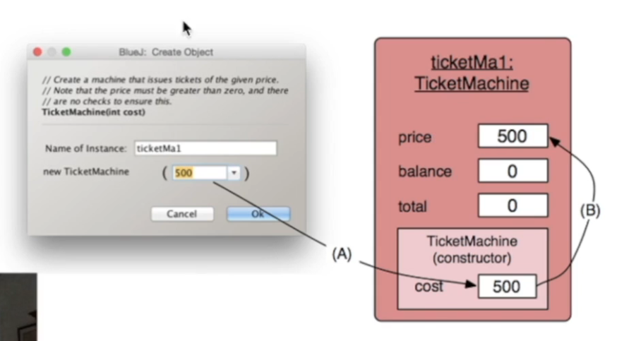

Values are stored into fields via assignment statements.
- Variables can only store one value so any previous value is lost.
- There is a lot of freedom over choice of names.
  - Choose expressive names to make code easier to understand.
  - Avoid single-letter or cryptic names.

Methods
Methods implement the behaviour of objects.
- Methods have a consistent structure comprised of a header and a body.
- Accessor methods provide information about an object.
- Mutator methods alter the state of an object.
- Other sorts of methods accomplish a variety of tasks.
The header tells us:
- The visibility to objects of other classes;
- whether the method returns a result (if it doesn’t, it will be a void type);
- the name of the method;
- whether the method takes parameters
The body encloses the method’s statements
public int getPrice()
Accessor methods are like this:
public int getPrice() → [visibility modifier] [type] [method name]([parameters])
{ → start of method body
return price; → [return statement]
} → end of method body
- Accessor methods always have a return type that is not void.
- An accessor method returns a value of the type given in the header.
- The method will contain a return statement to return the vlaue.
  - NB: Returning is not printing!

Mutator methods are like this:
public void insertMoney(amount)→ [visibility modifier] [type] [method name]([parameters])
{ → start of method body
balance=balance+amount → [expression of value being changed]
} → end of method body
- These have a similar method structure.
- They are used to make a change to an object’s state
- Achieved through changing the value of one or more fields.
It is possible to make a mutator that returns values. However, there is a good reason why we don’t do this.
Mutators that simply set the value of a method are called set mutator methods
public void setDiscount()→ [visibility modifier] [type] [method name]([parameters])
{ → start of method body
discount = amount → [assignment]
} → end of method body
- These are void return types
- Method name related to field name
- Single formal parameter, with the same type as the type of the field
- A single assignment statement

String Concatenation
public void printTicket()
{
[...]
System.out.println("# " + price + " cents.");
[...]
}
The act of putting strings together in an operation with multiple operands is called string concatenation.
- The variables in any concatenation operation is converted to strings.
Examples of string concatenation (and cases where it isn’t!)
- 4 + 5
  - 9
- “wind” + “ow”
  - “window”
- “Result: “ + 6
  - “Result: 6”

Conditional statements
General syntax for conditional statements:
[conditional prefix] ([condition]){
[statement]
}
- For conditional statements, we start the block on the same line as the conditional statement.
- If statements are about choices
  - if([I have enough money left]) {
[I will go out for a meal];
} else {
[I will stay home and watch a movie];
}

Variables
Fields are one sort of variable.
- They store values through the life of an object
- They are accessible throughout the class
Parameters are another sort of variable.
- They receive values from outside the method
- They help a method complete its task
- Each call to the method receives a fresh set of values
- Parameter values are short lived
Each block defines a new scope
- Class, method and statement.
- Scopes may be nested
  - Statement block inside another block inside a method body inside a class body
- Scope is static (textual)
- Lifetime is dynamic (runtime)

